- In web browser type the IP Phone IP address
- Username: admin
Password: 1234
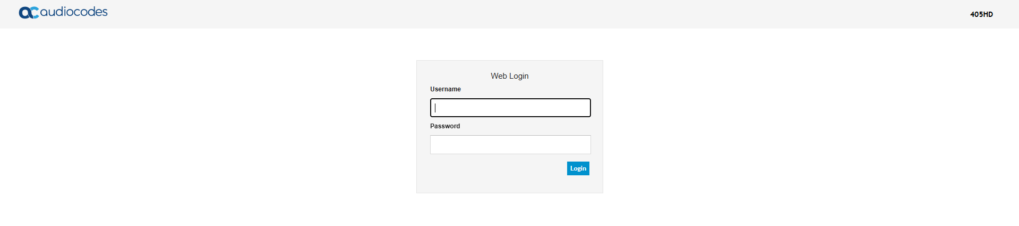
- Click Configuration > Voice Over IP > Media Streaming
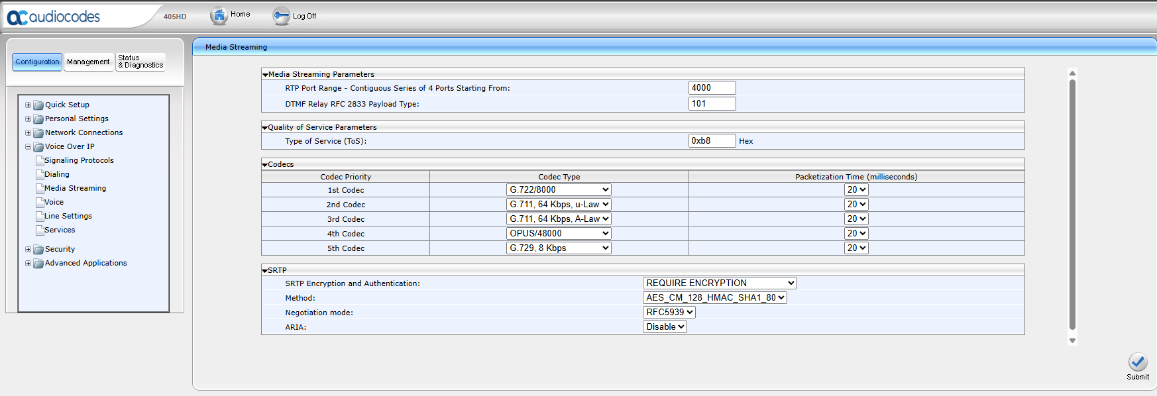
- Change the 1st codec to G.711,64Kbps, u-Law
Change the 2nd codec to G.711,64Kbps,A-Law
Change the 3rd codec, 4th codec 5th codec to None
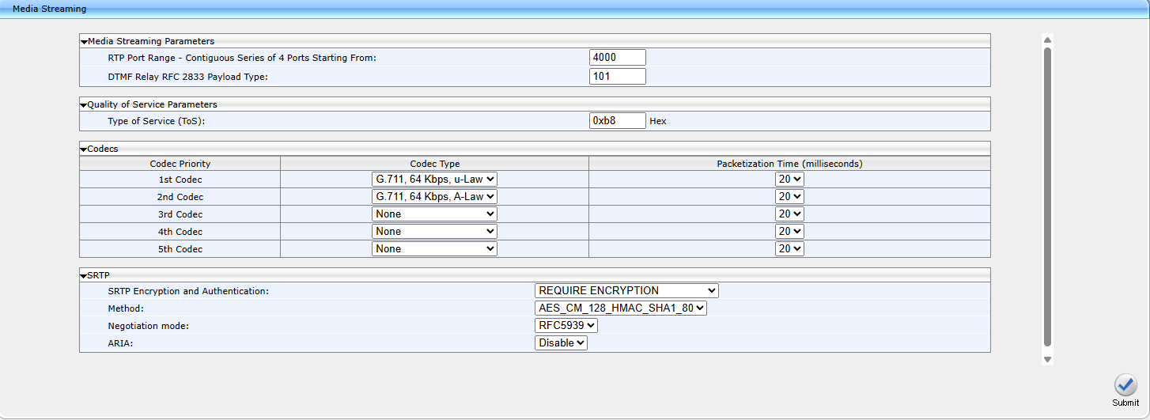
- Click submit

